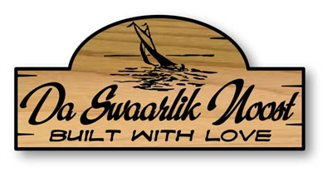  silhouette  7x16, 9x20, 11x24, 14x30, 16x42  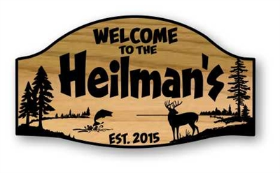  crest  7x18, 9x22, 11x28, 14x36, 16x40    eminere  9x20, 11x24, 14x30, 16x36    grunge battens  9x20, 11x26, 14x32, 16x36  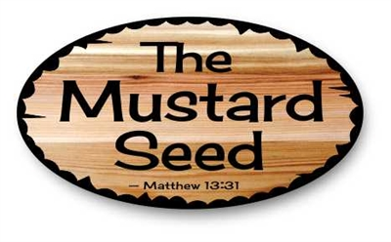  oval  9x16, 11x20, 14x26, 16x30  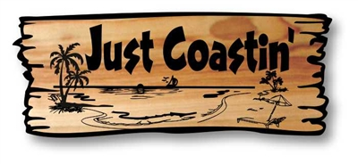  rustic rectangle  6x16, 7x18, 9x22, 11x28, 14x36  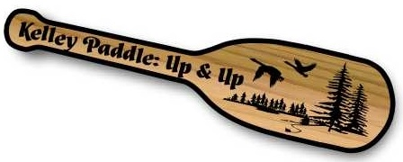  paddle  7x30, 8x34, 9x38, 10x42, 11x48  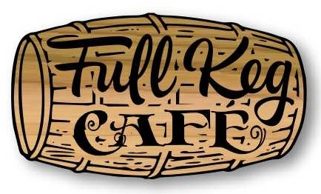  Barrel  9x16, 11x20, 14x24, 16x28    bear cloud  9x16, 11x20, 14x26, 16x30    bee hive  9x14, 11x16, 14x20, 16x24  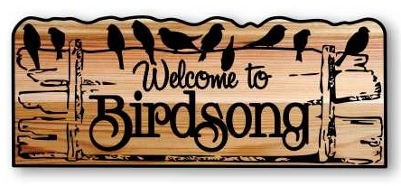  birds of a feather  9x22, 11x28, 14x34, 16x40  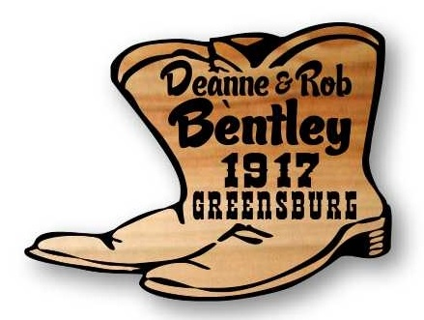  boots  9x14, 11x18, 14x24, 16x26  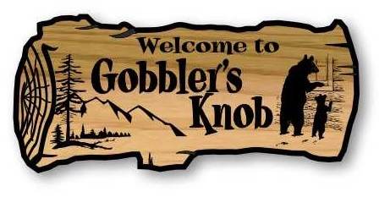  cedar log  7x16, 9x20, 11x24, 14x30, 16x36  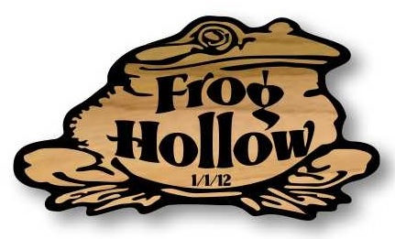  frog  9x16, 11x20, 14x24, 16x28  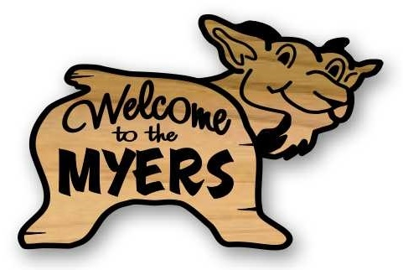  goat  9x14, 11x17, 14x22, 16x24  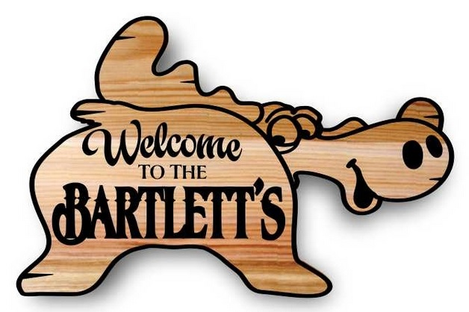  moose  11x18, 14x22, 16x24  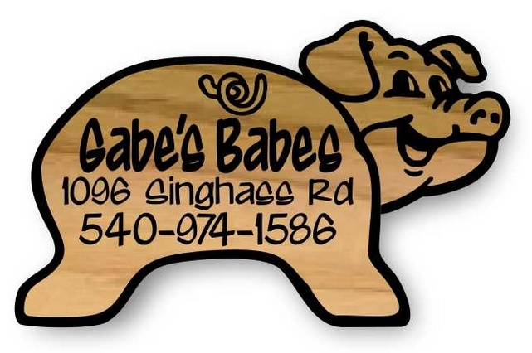  pig  11x18, 14x22, 16x24  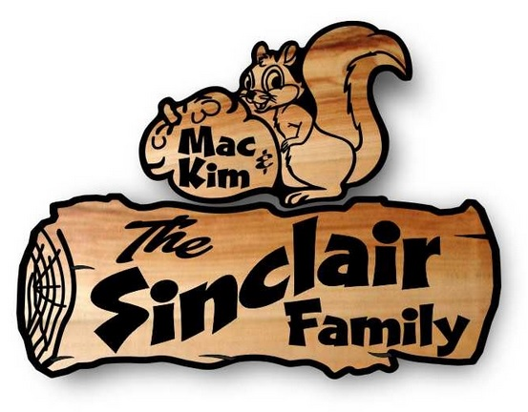  squirrel  7x16, 9x24, 11x30  bear cloud  9x168, 11x20, 14x26, 16x30  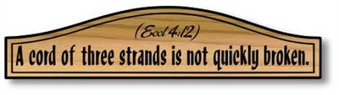  door crown  6x26, 7x30, 8x34, 9x40, 10x44, 11x48 | 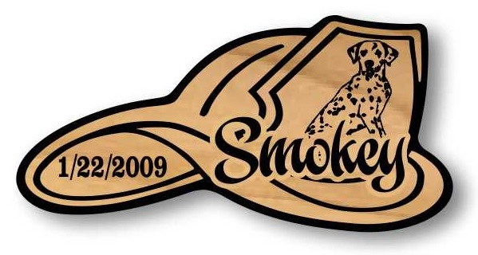  fire hat  9x18, 11x22, 14x28, 16x32    cowboy hat  9x20, 11x24, 14x30, 16x34  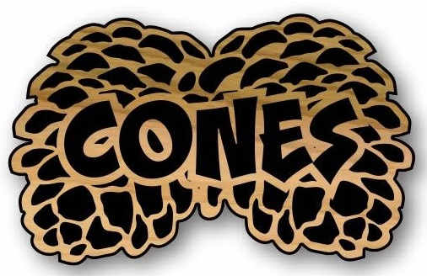  pine cone  11x17, 14x22, 16x26  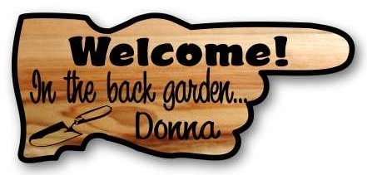  pointer  7x16, 8x18, 9x26, 10x24, 11x26, 14x32  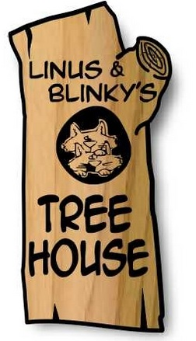  tree house  9x18, 10x20, 11x24, 14x28, 16x32  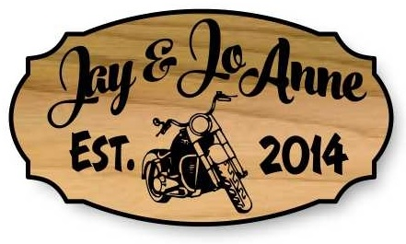  stylized oval  11+" Tall 1.5 stock  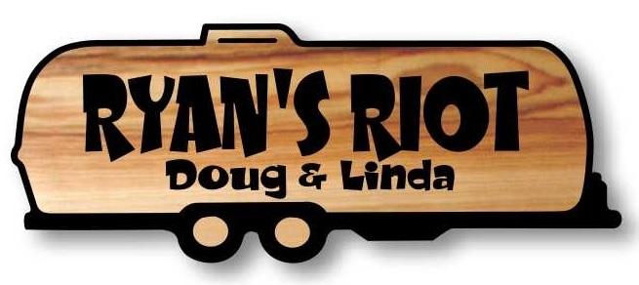  airstream 1  7x18, 9x24, 11x28  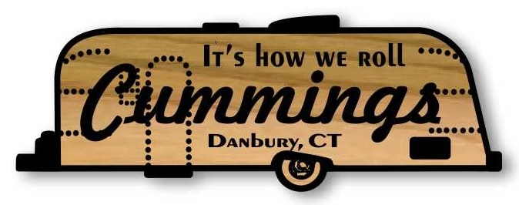  airstream 2  7x20, 9x24, 11x30  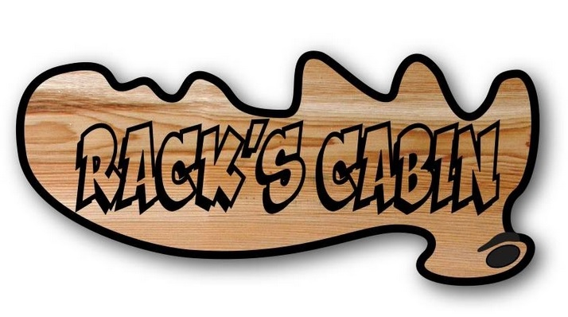  antler  9x20, 11x24  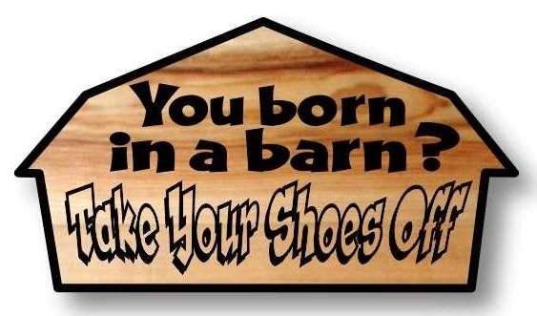  barn  9x16, 11x20, 14x26, 16x30    classy  7x18, 9x22, 11x28, 14x36, 16x40    rounds  6x20, 7x24, 8x26, 9x30, 10x32 11x36  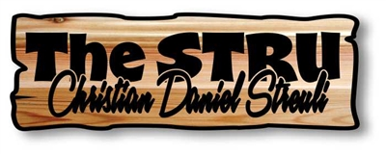  sentiment  6x18  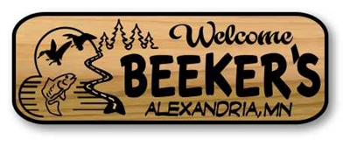  great outdoors  7x20, 9x26, 11x32, 14x40, 16x46  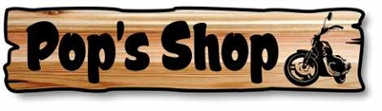  long wood  6x26, 7x30, 8x34, 9x40, 10x44, 11x48, 14x60  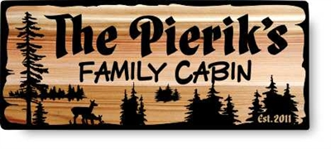  rectangle  7x17, 9x22, 10x24, 11x26, 14x34, 16x38  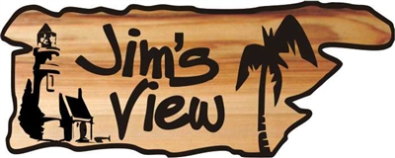  rustic pointer  11x14, 14x18, 16x20  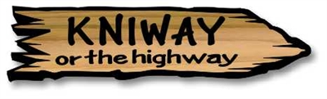  rustic arrow  6x24, 7x28, 9x36, 11x44  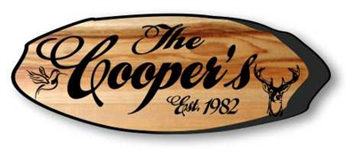  wood slice 3  7x14, 9x24, 11x30, 14x36, 16x42    lane and road  4x24, 5x30, 6x36, 7x42, 8x48, 9x54, 10x60    classic  9x18, 11x20, 14x26, 16x30 | 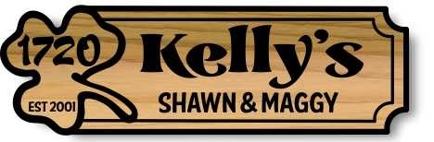  clover  6x18, 7x22, 9x28, 11x34, 14x44    drift wood effect  7x20, 8x24, 9x26, 10x28, 11x32, 14x40, 16x46    swagger  9x20, 11x24, 14x30, 16x36  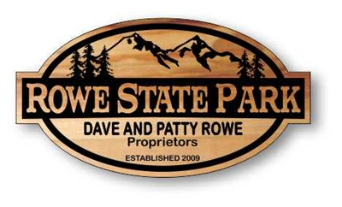  lodge  9x18, 11x20, 14x26, 16x30, 18x32  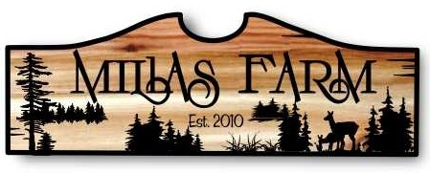  ogee top  7x18, 9x24, 11x30, 14x36, 16x42  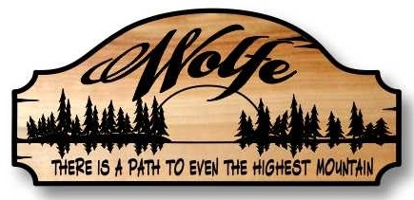  estate  7x16, 9x20, 11x24, 14x30, 16x34  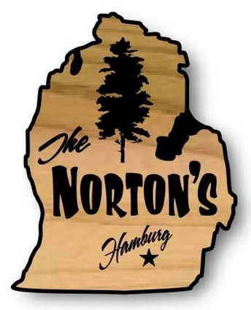  Michigan State  11x20, 14x20  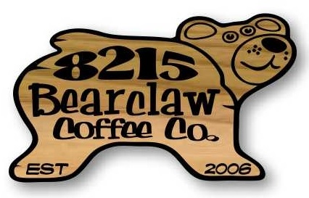  bear  9x16, 11x18, 14x22, 16x26  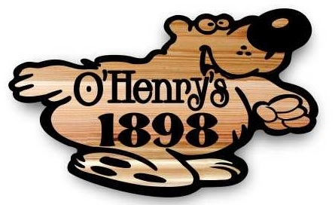  bear 2  11x18, 14x24, 16x26  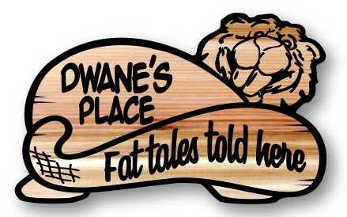  beaver  9x14, 11x18, 14x22, 16x26  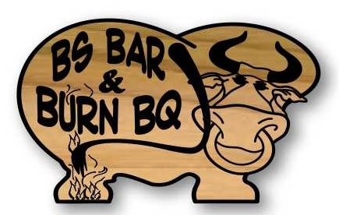  bull  9x14, 11x18, 14x24, 16x26  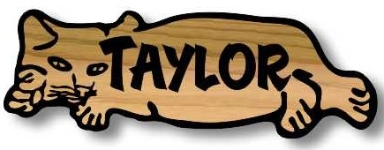  cat  10" (wall .75, desk 1.5)  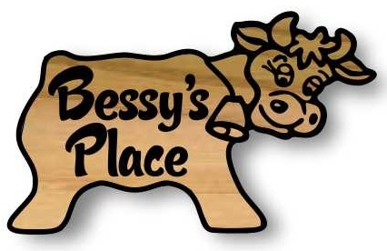  cow  9x14, 11x18, 14x24, 16x26    dog  9x14, 11x18, 14x22, 16x24  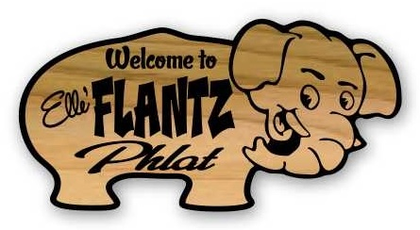  elephant  9x14, 11x20, 14x26  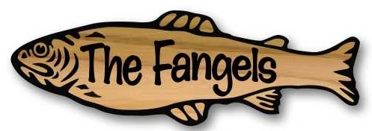  fish 1  10" (wall .75, desk 1.5)    fish 2  7x18, 9x24, 11x28, 14x36, 16x42  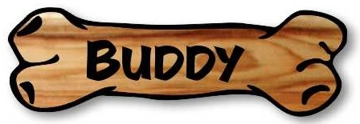  bone 10"  10" (wall .75, desk 1.5)  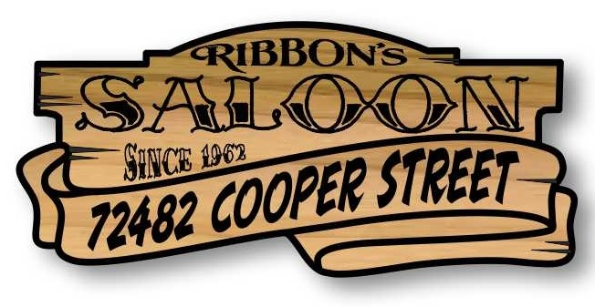  rustic ribbon  9x20, 11x24, 14x32, 16x36  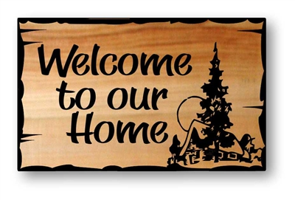  golden ratio  9x14, 11x17, 14x22, 16x26  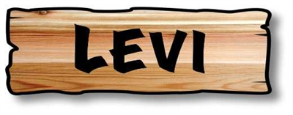  kids  10" (wall .75, desk 1.5) | 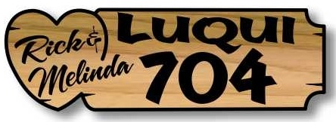  heart  7x22, 9x28, 11x34  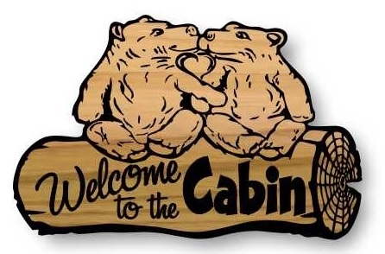  kissing bears  9x14, 11x17, 15x24, 24x30  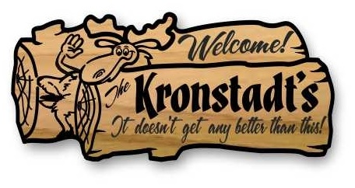  laughing moose  7x16, 9x20, 11x24, 14x30, 16x34  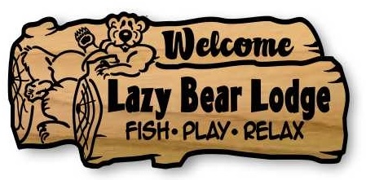  lazy bear  7x16, 9x20, 11x24, 14x30, 16x34  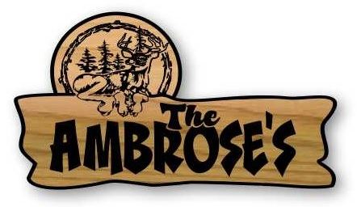  lazy deer  9x16, 11x20, 14x26, 16x30  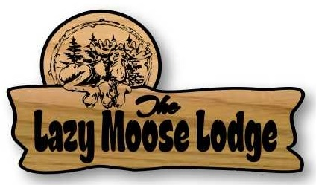  lazy moose  9x16, 11x20, 14x26, 16x30  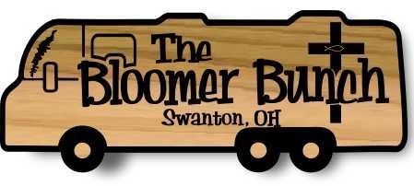  motor home 1  7x18, 9x24, 11x28, 14x36  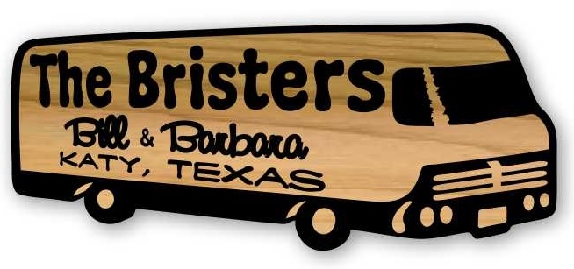  motor home 2  7x18, 9x24, 11x28, 14x36  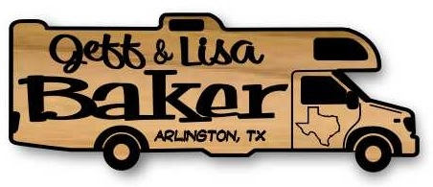  motor home 3  7x18, 9x24, 11x28, 14x36  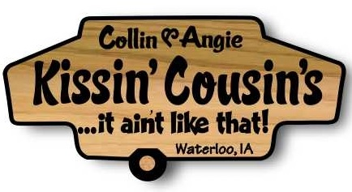  pop up  9x18, 11x22, 14x28  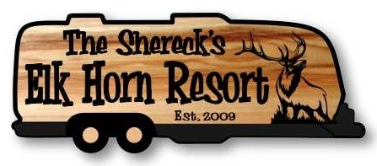  travel trailer 1  7x18, 9x24, 11x30, 14x36    trailer pod  8x16, 9x18, 10x20, 11x22, 14x28  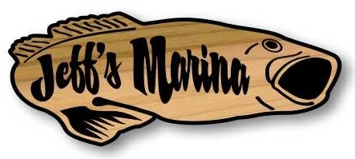  bass fish  7x18, 9x22, 11x28  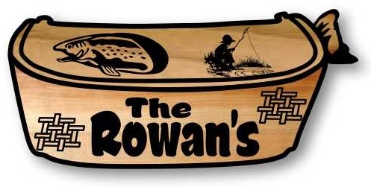  fishing creel  7x16, 9x20, 11x24, 14x30, 16x36  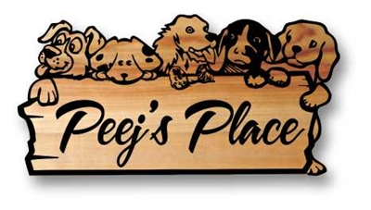  puppy box  9x18, 11x22, 14x28, 16x32  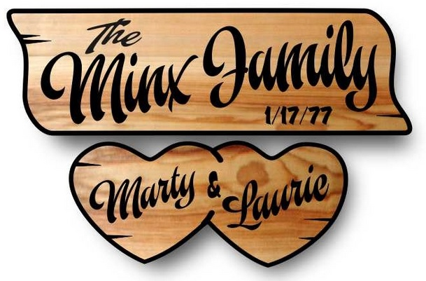  sweet hearts  6x16, 7x18, 9x24, 10x28, 11x32    double hearts  6x12, 7x16, 9x20, 11x24  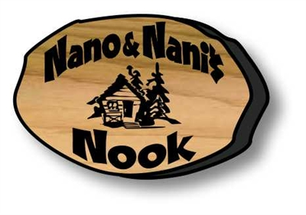  wood slice 1  9x14, 11x18, 14x22, 16x24  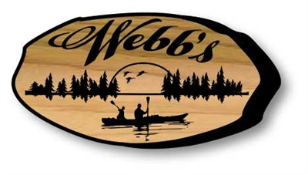  wood slice 2  7x14, 9x18, 11x22, 14x28, 16x32  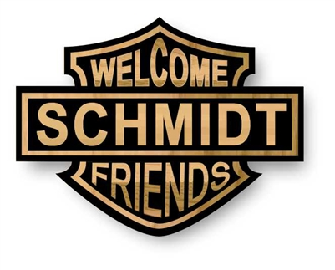  carved logo  11x14, 14x18, 16x20

